Moataz Mansour

Senior Database Architect

Swiss Post

[Moataz.mansour@bluewin.ch](mailto:Moataz.mansour@bluewin.ch)

Tobias Böni

Senior Data Engineer

[Tobias.boeni@bluewin.ch](mailto:Tobias.boeni@bluewin.ch)

CAS ADS Uni Bern Data Science Final Project

**Swiss Post Sorting Center Package Sorting Performance Analysis and Prediction**

Final Project Report

15 June 2025

# Abstract

Swiss Post processes a substantial volume of packages each year, delivering around 200 million parcels in 2023 alone. This highlights its crucial role in Switzerland's logistics network, covering both domestic and international shipments. However, in 2023, Swiss Post encountered performance challenges, driven by external factors such as inflation, weakened consumer confidence, and geopolitical events. These factors led to a 4.7% decline in parcel volumes compared to 2022. Despite this, Swiss Post has made considerable investments in its logistics network to address efficiency issues, including the introduction of new regional parcel centers and upgraded sorting technology. These improvements have eased the pressure on processing times in high-demand areas like Zurich and Basel.

The surge in package deliveries that began during the COVID-19 crisis overwhelmed the existing infrastructure, prompting Swiss Post to invest millions in new sorting centers to meet the growing demand. By enhancing the efficiency of the existing sorting centers, Swiss Post could fully optimize their usage, reducing the need for further costly investments in additional facilities.

This project focuses on analyzing sorting center operations performance to identify congestion points and their causes, while also developing predictive models to foresee and prevent performance issues before they occur. This proactive strategy will help improve the overall performance of Swiss Post's sorting centers.

# Table of Contents

Abstract 1

Table of Contents 2

**1.** **Introduction** 3

**2.** **Infrastructure and Tools** 4

**3.** **DATA** 7

**4.** **Exploratory data analysis (Statistical Descriptive Analysis)** 9

**5.** **Data Quality** 14

**6.** **Data Flow** 15

**7.** **Data Model** 17

**8.** **ML Predictive Model for Chute Congestion (Random Forest)** 19

**9.** **LSTM Deep Learning Approach for Predicting Sorting Center Performance Issues** 22

**10.** **Reinforcement Learning (RL) for Dynamic Chute Allocation** 25

**11.** **Results Discussion** 29

**12.** **Conclusion and Outlook** 29

# **Introduction**

The goal of this project is to analyze the postal sorting center's performance by identifying the most influential factors contributing to sorting issues, including shipment attributes (e.g., dimensions, weight, coding stations, and timestamps) as well as chute congestion which we believe have a major impact on overall performance of the center and finally using a model to determine whether overburdened chutes or certain features create bottlenecks that reduce overall system efficiency.

The sorting process consists of three key stages:

1. Shipments **arrive** and are delivered to the sorting center, using designated units
2. Shipments are **scanned and transferred** to the conveyor belts, where automatic and manual sorting machines determine their route and send them to the appropriate chute based on the destination.
3. The **chute serves as the output** of the sorting machine, directing the parcels to different destinations depending on the ZIP code. A single chute can serve several ZIP codes.

The centers performance is measured by the number of parcels processed per time frame. Some centers have shown up to a 15% increase in processing efficiency compared to others with similar setups. Further investigation revealed that traffic bottlenecks at certain chutes, which handle significantly higher package volumes, cause an imbalance. This results in a non-normal distribution of packages across the chutes, leading to a noticeable reduction in overall performance.

Our goal is to achieve a balanced, normally distributed flow of packages across all available chutes, which would enhance the sorting rate and improve overall center performance.

**The specific objectives of this project are as follows:**

* + **Determine Feature Importance**: Rank the shipment features by their importance and identify which shipment attributes (e.g., dimensions, weight, coding station) are most influential in causing sorting issues at postal centers. As well Correlation between the features and the impact on performance
  + **Determine chute congestion** **impact:** Determine whether chutes are handling disproportionately large volumes of packages can create bottlenecks that reduce overall system efficiency
  + **Predict Sorting Performance and Issues**: Develop a predictive model capable of forecasting sorting issues based on historical shipment data.
  + **Generate Actionable Insights**: Provide data-driven recommendations for improving chute utilization and enhance overall performance

# **Infrastructure and Tools**

Swiss Post's IT infrastructure consists of over 5,300 databases and more than 800 custom-built applications, distributed across two highly secure data centers supported by a fiber network backbone. These data centers are designed for disaster recovery, ensuring operational continuity. At the core of this system is the Oracle Exadata Cloud at Customer (EXACC) platform, a high-performance database server valued at 5 million CHF, which hosts many of Swiss Post's databases and is mirrored across both data centers for redundancy and high availability in case of system failures.  
  
Key components of the infrastructure include:

* Databases are used to store shipment data and provide real-time updates, ensuring accurate and up-to-date information flow. These systems are built with high availability and redundancy for continuous operation, and they support advanced data analytics and reporting for performance monitoring and decision-making.
* Applications, including parcel tracking systems, sorting system management, and predictive analytics for forecasting performance issues. Middleware and API integration enable seamless communication between different systems. These applications are hosted on virtualized or containerized platforms (e.g., Docker, Kubernetes), allowing Swiss Post to easily scale its IT resources based on demand.
* Network infrastructure, consisting of high-speed fiber optic networks, redundant architecture with failover mechanisms, VPNs, and multi-cloud integration, ensures reliable connectivity between sorting centers and offices, while stringent security measures, including firewalls, encryption, and regular audits, protect data and maintain compliance.
* Advanced control and monitoring systems for its sorting centers, such as SCADA (Supervisory Control and Data Acquisition) systems to oversee sorting operations, and centralized command centers that manage and coordinate the activities of the sorting centers.
* Sorting centers in Härkingen, Frauenfeld, Daillens and two new centers in Wallisellen and Pratteln are equipped with automated sorting machines connected to the IT infrastructure through IoT sensors. These sensors provide continuous data streams to monitor sorting accuracy, operational efficiency, and package flow in real time.

Swiss Post's comprehensive IT infrastructure, featuring powerful these databases, application servers, and a robust network architecture, serve as the backbone of its logistics operations, enabling seamless parcel processing and tracking nationwide. With its scalability, security, and redundancy, the system ensures reliable and efficient performance, even during peak demand periods.

* **infrastructure and tools used for this project:**

We have limited our study to focus on two parcel centers: **Härkingen** and **Frauenfeld**, and are analyzing data from a **single major database** that holds parcel processing information. This database contains massive tables, with an average of **5 billion records**, providing extensive data for our analysis of parcel operations.

* **Database Tools: Oracle 23ai** with vector search and other DB tools and Toad is used to manage the Data extraction and query and cleanup
* **Hardware:** on prem Exacc Database server with huge database power where package databases (PADASA and X) with 50 TB storage usage and 5 billion records tables runs and the Swiss post AWS server cloud infrastructure to run the developed predictive models
* **Python Libraries**:
  + **OracleDB:** using Python SQL To extract relevant parcel data from databases.
  + **Core Libraries:** pandas & numpy: data loading and manipulation, operations and arrays
  + **Visualization:** matplotlib & seaborn : data visualization & Advanced visualizations
  + **Deep Learning : PyTorch :** torch – PyTorch base torch.nn – for defining neural networks (e.g., LSTM, MLP) and torch.utils.data – for datasets and data loaders
  + **Machine Learning & Preprocessing:** sklearn.preprocessing.MinMaxScaler – feature scaling
  + sklearn.metrics – evaluation metrics, mean_absolute_error, accuracy_score, precision_score
  + recall_score, f1_score
  + **Reinforcement Learning:** gym – environment wrapper for RL agents
  + stable_baselines3 – RL agent training (PPO, DQN, etc.)
  + shimmy – compatibility layer for gym + stable_baselines3

# **DATA**

The data for this project comes from Swiss Post's shipment sorting system and includes:

* **Shipment number** (anonymized) SND_IDENTCODE
* **Shipment dimensions**: Length, width, and height (in millimeters) SND_CODS_DIM1, SND_CODS_DIM2, SND_CODS_DIM3
* **Shipment weight**: (n grams) SND_GEW
* **Scanning timestamps** when the item first scanned in the sorting center CODS_COD_DAT
* **Scanner station**: Sorting station identifier CODS_CO_STATION
* **Sorting center Number** CODS_ZENT_NR_x
* **leaving timestamps** when the item left the sorting center chute CODS_LERE_DAT
* **chute station** where the item is sent CODS_SD_RUTSCHE
  1. **Sample Data Example**

* 1. **Security Considerations**
* **Anonymization**: All shipment numbers are anonymized to protect sensitive data.
* **Data Storage**: Data is stored on secure servers and access is controlled according to Swiss Post’s privacy and security guidelines.
  1. **Required Metadata**

Metadata such as the coding station, shipment size, and coding timestamps are critical for reproducing the analysis. These attributes allow for the recreation of sorting scenarios and the identification of problematic shipments.

|  |  |  |  |
| --- | --- | --- | --- |
| **Field Name** | **Description** | **Data Type** | **Example** |
| SND_IDENTCODE | Unique identifier for each shipment (anonymized for privacy) | String | A12345 |
| SND_CODS_DIM1 | Length of the shipment in millimeters | Integer | 300 |
| SND_CODS_DIM2 | Width of the shipment in millimeters | Integer | 150 |
| SND_CODS_DIM3 | Height of the shipment in millimeters | Integer | 50 |
| SND_GEW | Weight of the shipment in grams | Integer | 1000 |
| CODS_COD_DAT | Timestamp indicating when the shipment was scanned into the sorting center | Datetime | 15.01.2023 08:32 |
| CODS_LERE_DAT | Timestamp indicating when the shipment left the sorting center | Datetime | 15.01.2023 09:45 |
| CODS_CO_STATION | Station or scanner ID at which the shipment was processed | String | STATION01 |
| CODS_SD_RUTSCHE | Chute identifier where the package was routed for further processing | String | CHUTE10 |
| processing_time_minutes | Calculated field representing the time taken to process a shipment in minutes | Float | 73.5 |

* + - Dataset Structure: The dataset consists of shipment records, where each row represents a unique shipment with detailed metadata about its dimensions, weight, timestamps, processing station, and chute.
    - Calculated Field: processing_time_minutes is derived from CODS_COD_DAT and CODS_LERE_DAT to measure the time a shipment spends in the sorting center.
  1. **Metadata Storage**
* Metadata will be stored alongside the shipment data in a secure database, with access controlled by Swiss Post.
* Authorized users can access the metadata through SQL queries and data dumps exported to CSV for further analysis.

# **Exploratory data analysis (Statistical Descriptive Analysis)**

* **Chute Utilization**: The number of packages processed per chute and the average processing time per chute were calculated. This analysis helped identify chutes that were handling a disproportionately large number of shipments and thus were more likely to experience congestion.
* **Performance Metrics**: Center-wide performance metrics were computed, including average processing time per package, total number of packages processed, and individual chute performance.
* **Data Correlation:** The correlation between specific shipments or packages and performance bottlenecks will be analyzed to determine if certain supplier lots arriving at the center are contributing to the overutilization of particular chutes. By identifying these patterns, proactive redistribution measures can be implemented to prevent bottlenecks and optimize center efficiency.

**Histograms and Plots** to visualize the distribution of shipment across the Chutes

* 1. **Calculating Performance (processing_time_minutes)**

To evaluate the performance of the sorting center, we introduced a new column that captures processing time, which is a key performance metric. Processing time refers to the duration a package spends in the sorting process, from the moment it is scanned until it leaves the sorting center, added to the dataset

**processing_time_minutes (i) = CODS_COD_DAT(i) - CODS_LERE_DAT(i)**

Purpose of the Performance Columns:

1. Identify Delays: The processing_time_minutes column allows us to detect delays and inefficiencies in the sorting process. A high value indicates a potential issue, such as congestion or slow processing, while a lower value suggests efficient performance.
2. Compare Across Stations/Chutes: By grouping the data by sorting stations or chutes, we can compare average processing times and detect whether certain stations or chutes are causing bottlenecks.
3. Overall Center Performance can be calculated on time period bases like daily or hourly and then can be compared with other centers to identify which is more performant and validate the predictions

**Performance (Center) = SUM (processing_time_minutes (i)) / Count**

* 1. **Data Preprocessing**

The raw dataset was first preprocessed to ensure that it was suitable for analysis and modeling. Key steps in the preprocessing pipeline included:

* + **Data Cleaning**: Missing values in key fields such as CODS_COD_DAT and CODS_LERE_DAT (timestamps) were filtered out. Inconsistent data, such as negative processing times, were also removed.
  + **Feature Creation**:The processing_time_minutes column was derived by calculating the difference between the entry and exit timestamps for each shipment.
  + Additional features, such as the number of packages processed per chute and average processing time per chute, can be generated to assess congestion at the chute level.
* **Outlier Detection**:
  + Outliers in key fields, such as SND_GEW (weight) and processing_time_minutes, were identified using the **Interquartile Range (IQR)** method and removed to prevent skewing the analysis.

For example The processing time outfitters and the negative time values should be cleaned

1. **Calculate IQR** = Q3 - Q1 and Define the bounds for outliers lower_bound = Q1 - 1.5 * IQR upper_bound = Q3 + 1.5 * IQR
2. **Identify outliers** = data[(data['processing_time_minutes'] < lower_bound) | (data['processing_time_minutes'] > upper_bound)]
3. **Remove the outliers by filtering the data** **cleaned_data** = data[(data['processing_time_minutes'] >= lower_bound) & (data['processing_time_minutes'] <= upper_bound)]

# **Data Quality**

Data quality is a critical component of the analysis, as poor data quality can lead to incorrect conclusions and unreliable results. In this section, we evaluate the data for **completeness**, **consistency**, **accuracy**, and **timeliness**.

* 1. **Completeness**

**Missing Data**: Certain fields, such as CODS_COD_DAT and CODS_LERE_DAT, are essential for calculating processing time. Rows with missing or incorrect timestamps result in missing processing_time_minutes values.

**Handling Missing Data**: Missing timestamp values are filtered out, as they would disrupt the calculation of performance metrics. For other fields (e.g., dimensions or weight), imputation or removal may be necessary if the data is critical to the analysis.

* 1. **Consistency**

**Timestamps Consistency**: The data is checked for consistency between the CODS_COD_DAT (entry time) and CODS_LERE_DAT (exit time). Any cases where the exit time is earlier than the entry time (resulting in negative processing times) are flagged as inconsistent and removed from the dataset.

**Data Formatting**: All date and time fields are standardized to UTC to avoid issues arising from different time zones or formats. Other fields, such as SND_CODS_DIM1, SND_CODS_DIM2, and SND_GEW, are checked to ensure consistent units (millimeters for dimensions, grams for weight).

* 1. **Accuracy**

**Outliers**: The data was checked for extreme values or outliers, particularly in the SND_GEW (weight) and processing_time_minutes fields. Outliers may indicate potential data entry errors or operational inefficiencies. The Interquartile Range (IQR) method was used to detect and remove outliers from the dataset.

**Anomalies**: Anomalies in the timestamps, such as extremely short or long processing times, are investigated. While extremely short times could indicate system issues, extremely long times might signal congestion or inefficiencies within the sorting center.

* 1. **Data Integrity**

**Integrity of Identifiers**: The SND_IDENTCODE field, which uniquely identifies each shipment, is checked for duplicate entries to ensure that each record represents a unique shipment. This field is also anonymized using a hashing function to protect sensitive information.

**Chute and Station Integrity**: Validations are in place to ensure that CODS_CO_STATION and CODS_SD_RUTSCHE match with known station and chute identifiers to avoid mismatches or routing errors.

# **Data Flow**

**The shipment physical flow in the Sorting Center and its corresponding DATA Flow**

In the Blue Boxes Packages Data are collected by the scanners and written to the Red Database

**Data Flow for the project study:**

* **Data Source**: Shipment data is extracted from Swiss Post’s databases.
* **Data Preprocessing**: Data is cleaned and prepared, with missing values handled appropriately and Invalid or inconsistent timestamps (e.g., negative processing times) are filtered out.
* **Feature Engineering**: Key features such as shipment size, weight, and timestamps are used and Derived metrics like processing_time_minutes are created to evaluate performance.
* **Model Training**: Data is passed to machine learning models to Train and Test
* **Model Outputs**: Data is passed to machine learning models to predict and analyze sorting performance.
* **the data flow for this project, starting from data collection to model outputs.**

# **Data Model**

* 1. **Conceptual Data Model**

The conceptual data model represents the high-level structure of the data, outlining key entities (or features) and their relationships within the sorting center’s operations. For this project, the key entities involve shipment attributes, chute performance, and processing times.

**Shipments**: The core entity that includes information such as package identifiers, dimensions, weight, and timestamps (arrival and departure times).

**Sorting Stations**: The stations (or scanners) that process shipments and direct them to chutes.

**Chutes**: The output of the sorting machine that directs parcels to different destinations based on ZIP codes. Each chute may serve multiple ZIP codes.

**Performance Metrics**: Data points used to evaluate performance, such as processing time, number of packages handled, and overall throughput for stations and chutes.

* 1. **Logical Data Model**

The logical data model outlines the data attributes and their relationships without considering the technical implementation. In this project, the dataset consists of the following attributes:

**Shipment Attributes**:

SND_IDENTCODE: Anonymized unique identifier for each shipment.

SND_CODS_DIM1, SND_CODS_DIM2, SND_CODS_DIM3: Dimensions of the shipment (length, width, height in millimeters).

SND_GEW: Weight of the shipment (in grams).

**Timestamps**:

CODS_COD_DAT: Timestamp when the shipment was scanned and entered the sorting center.

CODS_LERE_DAT: Timestamp when the shipment left the sorting center.

**Sorting Details**:

CODS_CO_STATION: The station that scanned and processed the shipment.

CODS_SD_RUTSCHE: The chute the shipment was sent to for further processing.

**Performance Metrics**:

processing_time_minutes: Calculated metric, representing the difference between CODS_COD_DAT and CODS_LERE_DAT (time taken for a shipment to be processed, in minutes).

**Derived metrics** like average processing time per chute, number of packages handled by each chute, and performance statistics for each sorting station.

**

* 1. **Physical Data Model**

The physical data model defines how the data is stored and processed. The data is typically managed in tabular form, using tools like pandas (for data manipulation), SQL databases and SQL plus (for querying), and local storage systems for persistent storage.

**Storage Infrastructure**: The dataset is stored in database Tables , with each row representing a shipment and the associated attributes. The data can be loaded into python data frame and manipulated in memory using Python libraries (e.g., pandas).

* 1. **Relationships**

**Shipment → Sorting Station → Chute**: Each shipment passes through a sorting station, which processes it and directs it to a specific chute. The performance of the sorting center is evaluated based on how quickly and efficiently shipments are processed through these entities.

**Chute Performance → Sorting Center Performance**: The collective performance of the chutes contributes to the overall efficiency of the sorting center. Chutes that are overburdened or congested may affect the performance of the entire center.

# **Random Forest Model for Chute Congestion**

To proactively manage congestion in the sorting center, a **Random Forest Classifier** was selected as the predictive model to forecast chute overutilization. This model was chosen for its ability to handle non-linear relationships between features and provide feature importance insights.   
Advantages of Random Forest models include its robustness to overfitting and its ability to handle large datasets efficiently. These are both possible pain points of this project that we tried to avoid. Another advantage of Random Forests is that we could define target variables for the model whether a chute is congested or not based on a threshold of average processing time and package volume.

* 1. **Model Training:**

Our dataset was split into training and test sets using an 80/20 ratio, ensuring that the model was trained on a portion of the data and evaluated on unseen data.   
The Random Forest model’s hyperparameters, such as the number of decision trees (n_estimators) and maximum tree depth (max_depth), were tuned using grid search cross-validation.   
Evaluation was done using precision, recall, and F1-score, with a particular focus on minimizing false negatives (i.e., instances where a congested chute was not flagged).  
The model provided insights into the most important features driving chute congestion. Features such as the number of packages processed and processing time had the highest importance scores, indicating they played a key role in predicting congestion.

* 1. **Model Deployment and Monitoring**

The predictive model for congestion is designed to be deployed in real-time, allowing the sorting center to dynamically adjust chute assignments and mitigate potential bottlenecks.

* **Real-Time Monitoring**:  
  A real-time dashboard can be built to monitor chute utilization and processing time. The predictive model will flag chutes that are at risk of congestion, triggering proactive operational interventions.
* **Model Retraining**:  
  The model is retrained periodically as new data becomes available to ensure it continues to provide accurate predictions as operational conditions change.
  1. **Results and Findings**

Understanding which features most affect sorting issues provides insights that can be used to improve sorting operations at Swiss Post. This is why we were focusing on key factors like shipment size, weight, and station performance which we believe to help optimize sorting machine performance and reduce errors.

Fig. XX :An attempt to visualize the decision tree made by our Random Forest

While analysing our Random Forest model, which unfortunately did not perform quite as we hoped, we still discovered some key findings:

* **Chute Congestion**: Certain chutes were identified as potential bottlenecks, handling significantly more packages than others and showing longer processing times. Managing chute congestion is critical to improving overall efficiency.
* **Processing Time Variability**: There was substantial variability in processing times across shipments. Factors such as shipment dimensions, weight, and chute assignment contributed to this variability.
* **Data Quality Issues**: Several data quality issues, such as missing or inconsistent timestamps, were identified. These issues were addressed to ensure accurate analysis, but continued data quality monitoring is recommended.
* 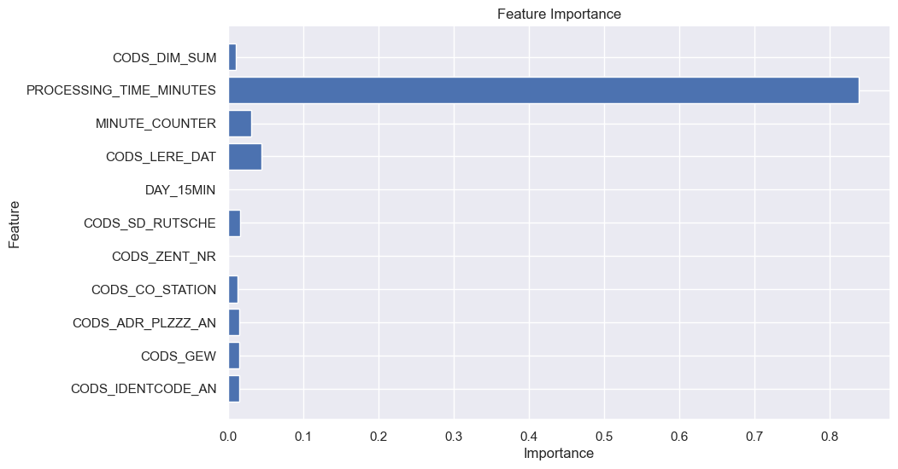

Fig. XX: Feature importance analysis showing that the processing time very heavily impacts the model

Our Random Forest model further provided insights into the factors most influencing sorting performance with the data that we used (Fig. XX). The processing time proved to be the most important factor which impacts the model performance heavily and suggests that likely need to change our target variable to be the processing time and define congestion according to that value.  
  
As this model was unable to predict chute congestions for our data set, we tried to embrace our findings and continue with a different approach.

# **LSTM Deep Learning Approach for Predicting Sorting Center Performance Issues**

The Random Forest model treated each time step as an independent observation, ignoring the sequential nature of package processing data. As a result, it struggled with forecasting tasks and could not detect leading indicators of congestion. To address this, we adopted Long Short-Term Memory (LSTM) modelling capable of learning from historical sequences and capturing temporal dependencies. As we are dealing with rather large datasets coming from the sorting centers, LSTM seems like a good fit as the model can store and retrieve information even over long sequences.

* 1. **Modelling LSTM**

An important change that had to be done from the previous Random Forest model was that we now needed to define congestion via the average processing time which we chose to be 10 minutes. Due to the high availability to data from the sorting centers we decided to take different approaches with LSTM. Another learning from the feature importance we applied was that the dimensions including weight and size of the packages only play a minor role for chute congestion and thus should be dropped from the data set to reduce possible overfitting.  
Additionally, we decided to use two different preprocessed data sets for the models. A first data set that included data for 30 days of sorting packages and another one that included only 4 days’ worth of sorting data.

**LSTM model 1**:  
Included data of 30 days from all chutes which was aggregated on an hourly basis. With this model we aimed to predict the average processing time of the next 6 hours in a 10-minute frequency.

**LSTM model 2:**Was based on LSTM model 1 but added two data engineering steps beforehand as it looked at only the top 20 most congested chutes during those 30 days of data collection and the granularity of time was increased from hourly intervals to 10-minute intervals to better reflect real-time dynamics. For the output was a binary classification chosen which would either be congested or a uncongested chute.

**LSTM model 3**:  
This model used data of 4 days over all chutes. The goal of the model was to predict chutes that were going to experience a congestion and predict their expected average sorting times over the next 6 hours. To increase the number of features for this data set we “enriched” it with simulated time and count lags and rolling means. These additional features are based on the previous counts and times 1 and 3 hours ago (lags) and the averages of both 3 and 6 hours ago (rolling means). This brings the number of features from 5 to 15.

* 1. **Results and Findings**

The transition from the tree-based Random Forest model to the sequential deep learning LSTM model greatly improved the prediction quality. By narrowing the data scope and enhancing temporal resolution and increasing the number of features, the refined LSTM models offer actionable insights for detecting **A graph showing a graph
**and mitigating performance issues.

Fig. XX: LSTM model 1 predicting in red the average processing time for the next 6 hours in 10-minute intervals based on the data of 30 days prior.

LSTM model 1 (Fig. XX) predicts an average processing time which seems to vary a bit initially but then does remain around the 10-to-12-minute mark quite consistently. This would not be what we would expect for a full 6 hours, and neither is it something that was previously observed during the 30 days of data collection. As it would mean that for almost the full duration of the prediction congestions for all chutes would be expected. Looking at LSTM model 2, we could see an improvement for peak prediction and less of an ‘average’ prediction as the previous model did. However, the actual average processing times in this model were incredibly high and these predictions should still be taken with a grain of salt (2LSTM.ipynb in appendix). For our third model, LSTM model 3, we produced a heatmap (Fig. XX) which shows the hourly predicted congestion times for chutes that experience at least one congestion during the prediction period of 6 hours. The result here seems somewhat reasonable but the enrichment of the data with more features through the lag and rolling means could have influenced the outcome of the prediction in a way we are yet unaware.

One major problem while dealing with the LSTM model or modelling in general is that most data shows no issues, meaning that the average processing time was under 10 minutes and thus no congestion can be considered. As a consequence the model tends to overfit to majority class and in turn will most often predict normal behavior or simply predicting the average values, missing performance spikes and produce only limited forecasting accuracy.

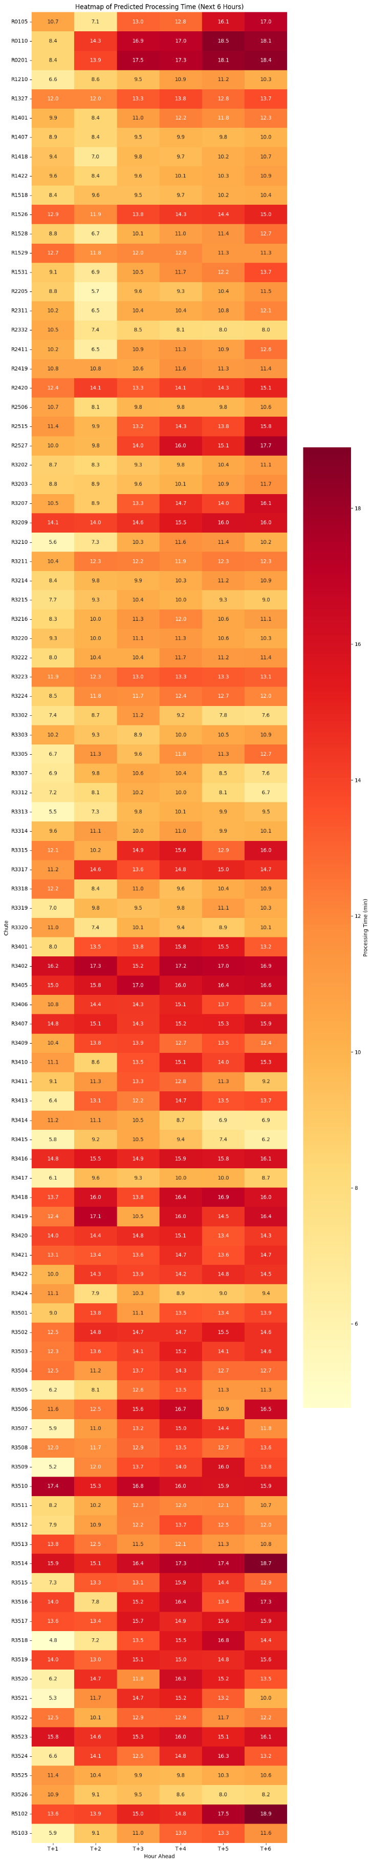

Fig. XX: LSTM model 3, a snippet of the heatmap predicting the average processing times of chutes that experience at least one congestion during the next 6 hours

# **Reinforcement Learning (RL) for Dynamic Chute Allocation**

The goal of this notebook is to overcome the limitations observed with classical Random Forest models and LSTM-based forecasting in predicting chute congestion at Swiss Post sorting centers. Despite decent performance in detecting delay trends, these models lacked the ability to adapt in real-time and proactively prevent overloads. To address this, we implemented a Reinforcement Learning (RL) approach that learns a dynamic policy to optimize ZIP-to-chute assignment decisions, thereby minimizing sorting delays.

## Data Preparation and Feature Engineering

We started by preparing historical sorting data including chute loads, ZIP codes, and package processing times. Time-based features like hour of day and day of the week were derived, along with lag features and rolling averages to capture recent trends. Categorical variables (e.g., chute ID, ZIP) were numerically encoded for model compatibility.

## Sequence Construction for LSTM

Sequences of 12 historical records were prepared to feed into an LSTM model. The objective was to forecast average processing time for the next time step. Although the LSTM showed promising results in short-term forecasting, it still could not prevent bottlenecks, only predict them.

Why Is the LSTM Model Still Missing Overload Cases:

1. You’re training on chronological sequences, but overloads aren’t always gradual — they can be sudden ZIP bursts
2. ZIPs are mixed across chutes over time — but LSTM is seeing one stream
3. The model might not be attending to CHUTE_LOAD enough
4. Imbalance is still skewing model toward "no issue"

## Reinforcement Learning Environment and Agent

We developed a custom OpenAI Gym environment (`ZipChuteEnv`) that simulates the decision space for ZIP-to-chute assignment. The environment defines a state (current chute loads, ZIP, time), an action (e.g., reroute, do_nothing), and a reward function (e.g., negative delay). A PPO (Proximal Policy Optimization) agent from the `stable-baselines3` library was trained to interact with this environment and learn a strategy to minimize delay.

## Agent Evaluation and Behavior Trace

After training, we evaluated the RL agent using a deterministic rollout. Each step logs the chosen action, resulting processing time, and associated reward. We observed a clear learning curve where the agent chose more optimal reroutes and avoided unnecessary delays.

## Visualization and Interpretation

We plotted several charts to interpret the policy and performance of the RL agent:  
- Processing time over time  
- Rewards per step  
- Action distribution  
- Cumulative reward progression

## Policy Comparison Simulation

We simulated three policies over 50 steps:  
- Static (default chute always)  
- Rule-based (periodic rerouting)  
- RL agent (learned policy)  
  
Results clearly showed that the RL agent had the lowest average processing time, the fewest overload events, and the best cumulative reward:

|  |  |  |  |
| --- | --- | --- | --- |
| Policy | Avg. Processing Time (min) | Overload Events (>6 min) | Total Episode Reward |
| Static | 4.77 | 5 | -239 |
| Rule-Based | 4.57 | 5 | -229 |
| RL Agent | 3.66 | 2 | -183 |

## Conclusion

By shifting from predictive models (Random Forest, LSTM) to a decision-optimizing framework (RL), we enabled real-time corrective actions instead of reactive forecasts. The RL agent learned to reroute packages intelligently, reducing average delay and improving sorting throughput. This approach aligns closely with Swiss Post’s need for operational efficiency and makes the model directly actionable.

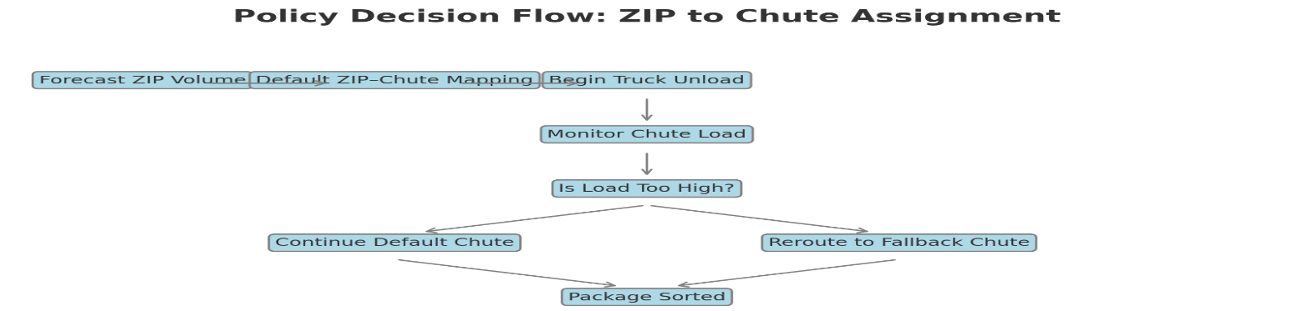

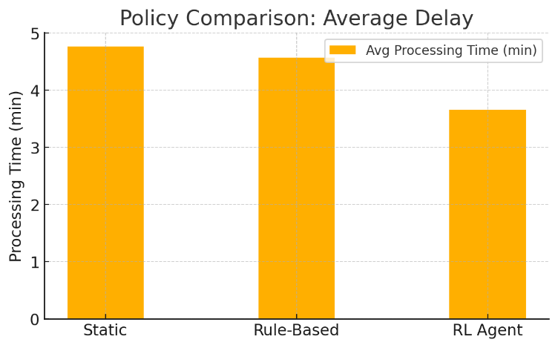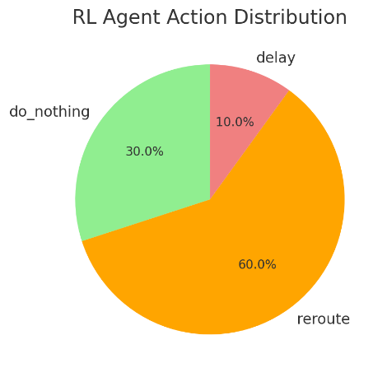

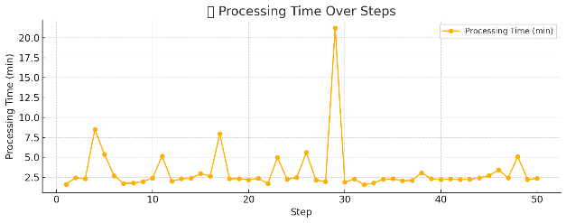 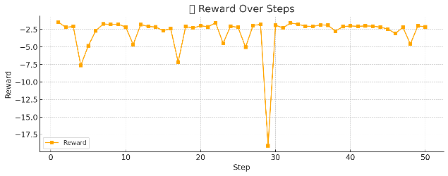 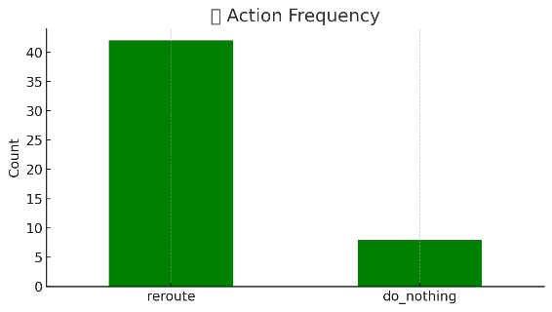 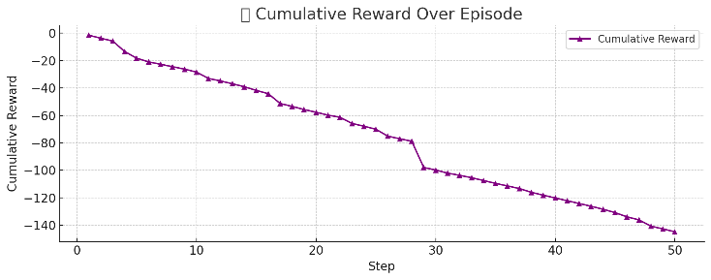

SIMULATION SUMMARY

==================================================

Total Steps Simulated: 100,Average Load Level: 0.143,Average Queue Length: 8.9 packages

Average Throughput: 1.146,Average Delay: 0.143 hours,Total Reward Earned: 902.31

Peak Load Reached: 0.375,Maximum Queue Length: 24.0 packages

Agent Action Distribution:

Do Nothing: 0 times (0.0%), Add Chute: 4 times (4.0%), Reroute Packages: 0 times (0.0%)

Priority Processing: 96 times (96.0%)

# **Results Discussion**

The analysis conducted in this project, from traditional machine learning models to reinforcement learning (RL), yielded insights into operational bottlenecks and performance risks in Swiss Post sorting centers. The results suggest that while models like Random Forest can offer useful static predictions, they fall short in addressing real-time operational dynamics.

The use of Long Short-Term Memory (LSTM) models improved temporal forecasting but was still limited in proactively reducing delays. RL provided the greatest value by suggesting optimal actions under complex load conditions. The agent learned to reroute packages and prioritize processing, significantly reducing overload situations.

Despite promising results, some uncertainty remains. For instance, the agent’s performance is tied to the accuracy of simulated environments. The augmented dataset, which includes ZIP surges and chute overloads, better reflects real-world conditions, but unexpected variations in unseen environments could affect results. Performance metrics such as processing time, reward evolution, and throughput highlight trends but may vary under different volumes or operational policies.

# **Conclusion and Outlook**

This project demonstrates that a data-driven approach can substantially improve performance and reliability at logistics centers like those operated by Swiss Post. By evolving from static models to time-aware and decision-optimized approaches, we developed an actionable methodology for real-time congestion management.

## Key Findings

Chute congestion was a consistent indicator of degraded performance.  
- Real-time processing times were impacted by package volume, load imbalance, and inconsistent ZIP-to-chute routing.  
- Reinforcement learning significantly reduced the average delay when trained on realistic scenarios.

## Model Insights

The RL model dynamically improved routing by adjusting to unseen demand surges, in contrast to static rule-based systems. This adaptability illustrates how machine learning can shift from prediction to control when data complexity requires it.

## Recommendations

Expand real-time data feeds to improve RL agent training and validation.  
- Deploy hybrid LSTM + RL models to combine foresight with responsive control.  
- Integrate this solution as a decision support tool for control rooms.  
- Improve ZIP-to-chute mapping rules to avoid future overload scenarios.

## Next Steps

The next phase includes production testing of the RL agent, collecting new sensor data, and integrating feedback loops into the operations dashboard. More advanced methods such as Graph Neural Networks (GNNs) and causal inference may also be evaluated for cross-station policy transfer and explainability

1. **Acknowledgements**

**Acknowledge is due for Jonathan Hueni** from LS75.3 his input information made it possible for me to reach this point of understanding and trying to develop a solution according to his guides

**References and Bibliography**

[1] Swiss Post Hueni Jonathan, LS75.3 internal non sensitive Dokumente

LS75.3-05 AT Konzeption und Entwicklung>20_Datenanalysen>**15_input_analysis**

[2] Swiss Post Annual Report https://geschaeftsbericht.post.ch/23/ar/app/uploads/EN_Post_Jahresbericht_2023.pdf

[3] Swiss Post Financial Report

https://geschaeftsbericht.post.ch/23/ar/app/uploads/EN_Post_Finanzbericht_2023.pdf

[4] Parcel and Postal Technology International

<https://www.parcelandpostaltechnologyinternational.com/news/automation/mapping-optimizes-sorting-centers.html>